Adding a Windows server 2022 on a network with 2012R2 as DC
- Current status of RSDC003 not able to replication SYSVOL folder with new windows server 2022
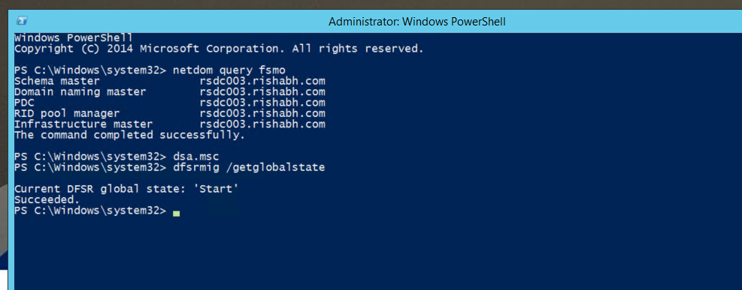
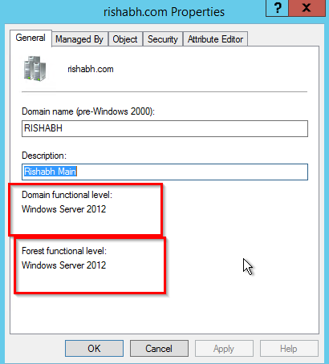
WE need to convert SYSVOL replication method from DFS to DSFR
On our both AD servers’ s status showing are “Start” = AD using FRS,
(“Start” = AD using FRS, “Eliminated” = AD using DSFR)
Need to change status from Start to Be Eliminated (use below command on primary AD)
- Repadmin /replsummary - check replication between RSDC003 and RSDC004
- dsa.msc - check domain functional level
- dfsrmig /getglobalstate-We want to check what SYSVOL replication is used in our current environment

- dfsrmig /getmigrationstate
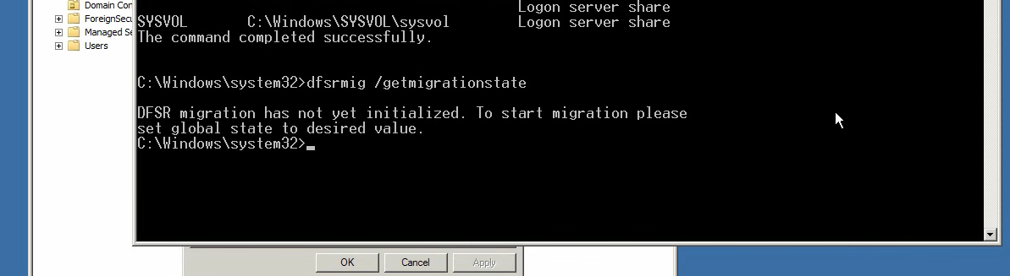

There are 4 migration state
- - start
- - Prepared
- -Redirected
- -Eliminated

- dfsrmig /setglobalstate 1 - (Fist task is to migrate the DFSR state to Prepared )
it will take 15 to 20 minutes to change status

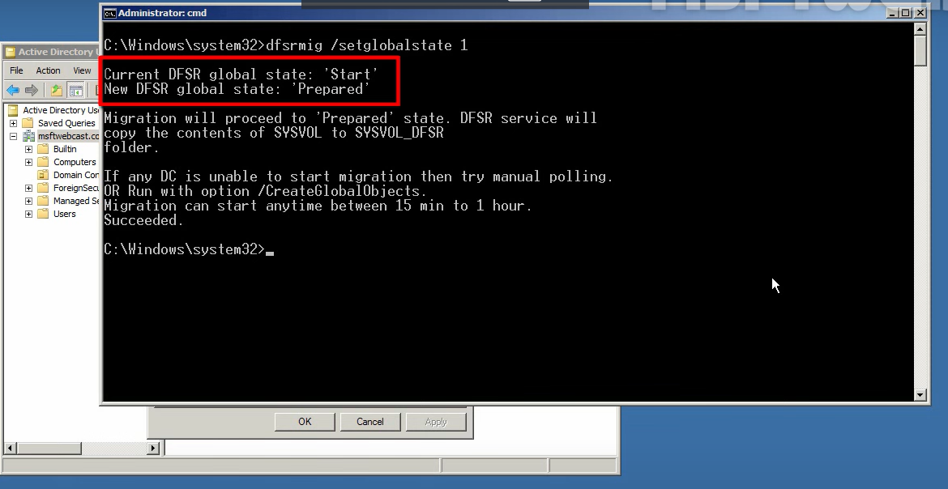

- dfsrmig /getmigrationstate - check status

it will be showing single domain in status also we can check from new SYSVOL-DFSR folder automatically
created by this process
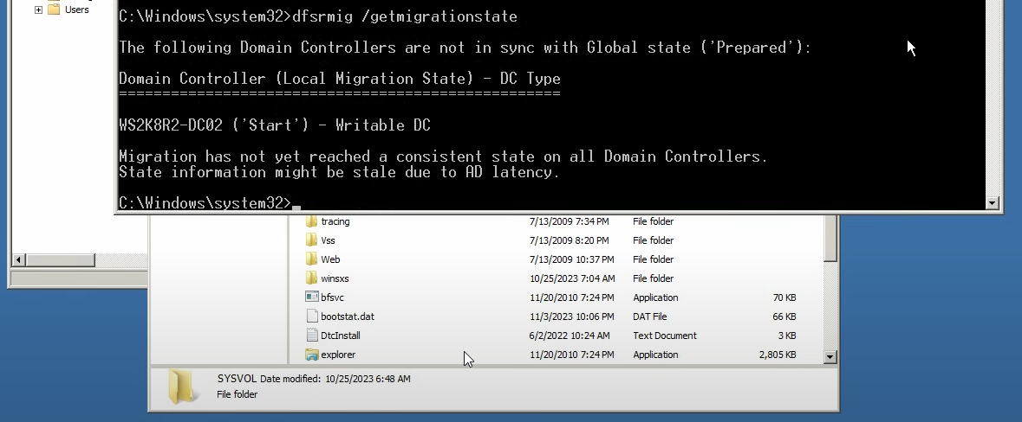
Once the migration is complete showing below status
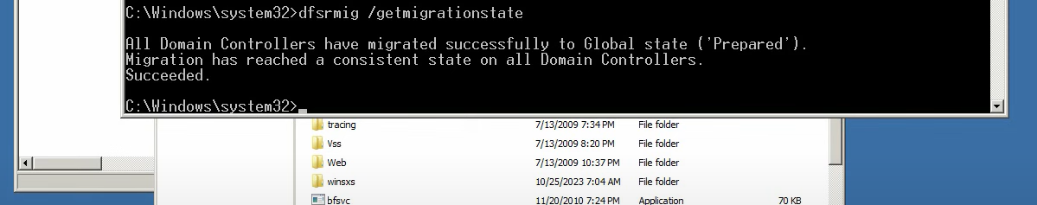

- dfsrmig /setglobalstate 2 - (Second task is to migrate the DFSR state to Redirected )
it will take 15 to 20 minutes to change status

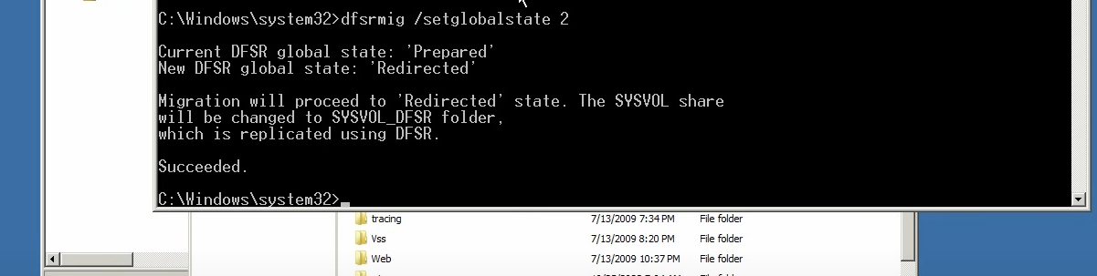

- dfsrmig /getmigrationstate - check status
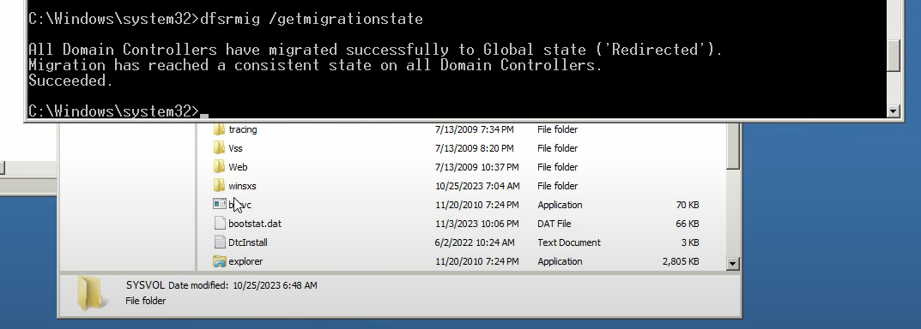

- dfsrmig /setglobalstate 3 - (final task is to migrate the DFSR state to Eliminated )
it will take 15 to 20 minutes to change status
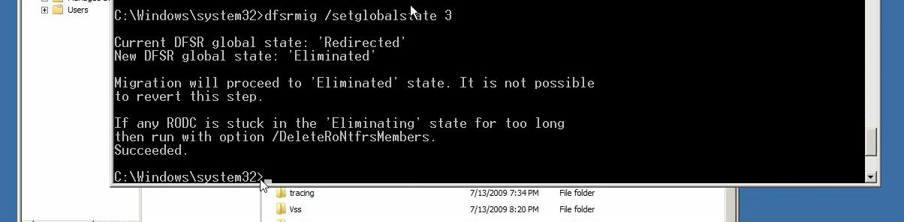
- dfsrmig /getmigrationstate - check status
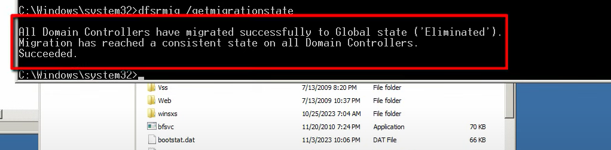

With this the migration of SYSvol folder from FRS to DFS is replication started
- net share
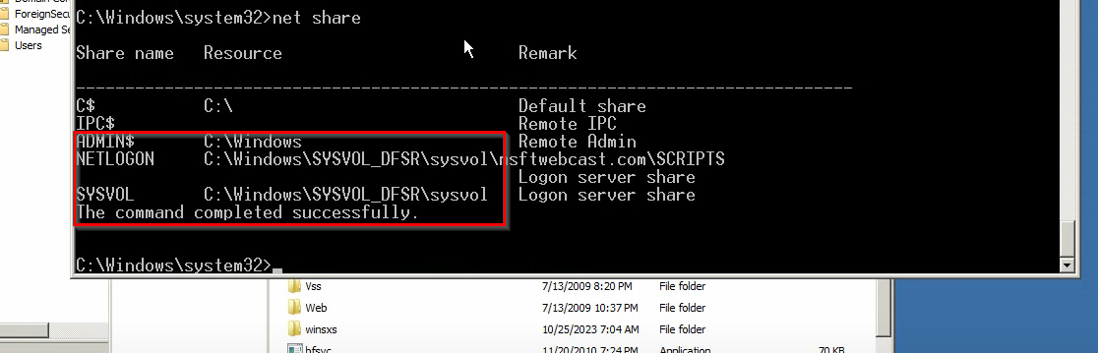

Check service file replication service is stop and disabled
Check same status on both AD
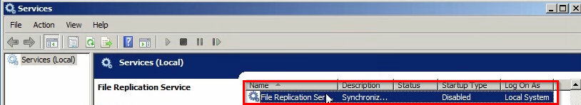

SYSVOL replication process completed now we can add windows server 2022 as additional domain controller

Testing on Test server
from server 2012 to 2022 SYSVOL replication we required convert DSFR to Eliminated
Dfsrmig /getmigrationstate"

SYSVOL replication from FRS to DFSR - We need to do this activity
Repadmin /replsummary
- Repadmin /replsummary - check replication on Test server
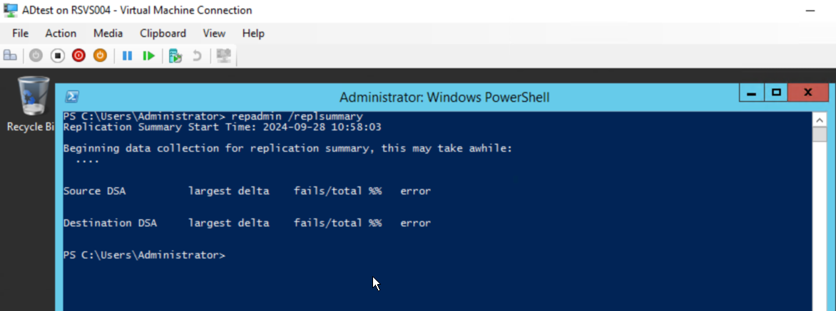
- Dsa.msc
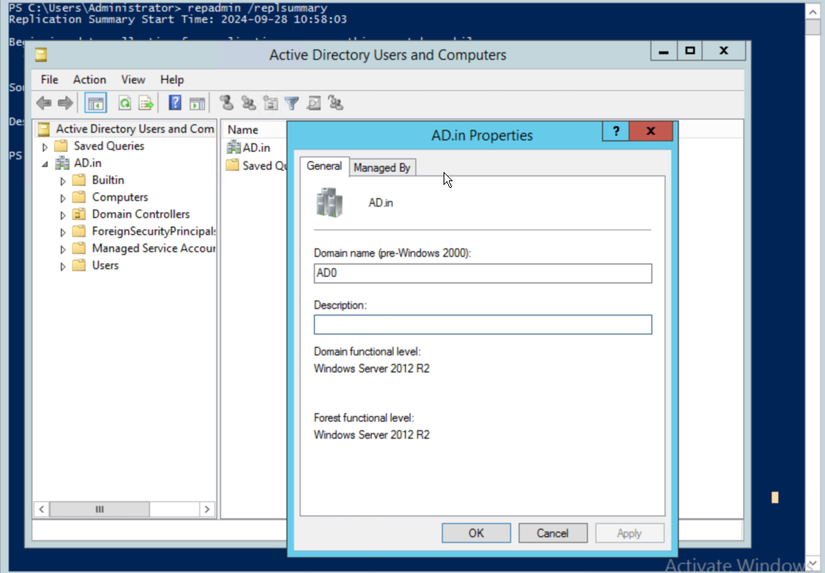
- Before and change on AD , Check client systems domain
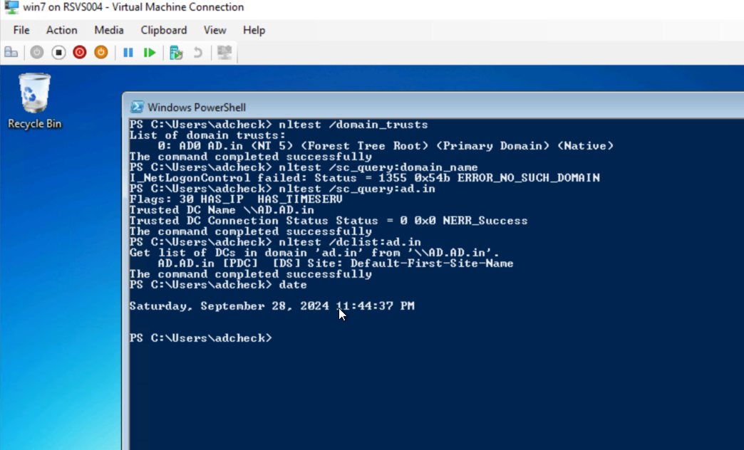
4. dfsrmig /getglobalstate - We want to check what SYSVOL replication is used in our current environment
Test server is already on Eliminated state
